Demonstrating Sustainable Biomass Utilization and Processing using Ionic Liquids – an Introduction to Undergraduate Chemistry Laboratories

Daniel Rauber¹⁾²⁾, Michael Conrad¹⁾, Johannes Huwer¹⁾, Harald Natter¹⁾²⁾, Rolf Hempelmann¹⁾²⁾*

1) Department of Physical Chemistry and Chemistry Didactics, Saarland University, Campus B2.2, 66123 Saarbrücken, Germany.
2) Transfercentre Sustainable Electrochemistry, Saarland University and KIST Europe, Campus Dudweiler, Zeile 3, 66125 Saarbrücken.
Content:

1. Synthesis of the Ionic Liquids S1
1.1 Synthesis of 1-butyl-3-methylimidazolium-chloride [C₄-mim][Cl] S1
1.2 Synthesis of triethylammonium methanesulfonate [Et₃NH][SO₃Me] S4
2. Full hazards and precaution statements for the chemicals used in the main manuscript S6
3. The twelve principles of green chemistry as guideline for sustainable development in chemistry S7
3.1 Introduction of the green chemistry guidelines S7
3.2 Evaluation of the experiments in the context of green chemistry S8
3.2.1 Biomass pretreatment using ionic liquids S8
3.2.2 Biomass processing using ionic liquids S10
3.2.3 Biopolymers based on lignin S12
4. NMR-spectra of the synthesized ILs. S14
4.1 NMR-spectra of [C₄-mim][Cl] S14
5. References S16

1. Synthesis of the Ionic Liquids
This chapter describes the synthesis of the two ionic liquids (ILs) used in the main manuscript. They can be synthesized from readily available, inexpensive chemicals; [C4-mim][Cl] can be obtained from a variety of commercial suppliers. By evaluating the yield, time and energy demand a comparison about the environmental friendliness of the two syntheses can also be made. Make sure to wear appropriate protection during the synthesis and handling including gloves, lab coat and safety googles to avoid any harm. The obtained ILs are hygroscopic and should therefore be stored in sealed vessels to avoid contact with moisture.

1.1 Synthesis of 1-butyl-3-methylimidazolium-chloride [C₄-mim][Cl]
The synthesis of the ionic liquid 1-butyl-3-methylimidazolium chloride [C₄-mim][Cl] is carried out according to scheme 1 without solvent. In principle the experiment can be scaled up or down according to individual needs without any further changes.
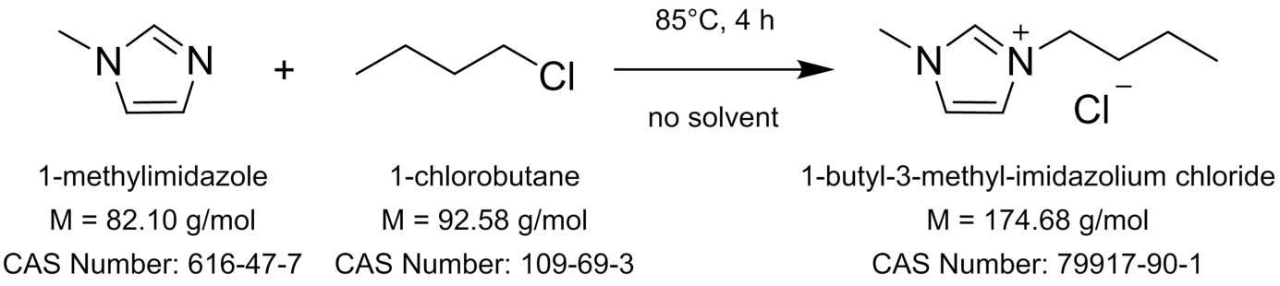
Scheme 1. Synthesis of [C₄-mim][Cl] by nucleophilic substitution of 1-methylimidazole and 1-chlorobutane.
Equipment and glassware: 250 mL three-necked round bottom flask, 250 mL round bottom flask, reflux condenser, thermometer with adapter, dropping funnel, graduated cylinder, magnetic stirrer, magnetic stir bar, oil bath, 500 mL beaker, rotary evaporator or distillation apparatus, oil-pump and cooling trap (optional).
Chemicals: 1-methylimidazole, 1-chlorobutane, ethyl acetate. The corresponding GHS-classifications along with hazard and precaution statements are listed in Table 1. The amounts of substances for 100 g theoretical yield are given in Table 2.

Table 1. GHS-classification along with hazards and precaution statements for the synthesis of [C4-mim][Cl].
Substance name | CAS Number | GHS-classification | H-phrases | P-phrases
1-methylimidazole | 616-47-7 | GHS05, GHS06 | H302-H311-H314 | P280-P301 + P312 + P330-P303 + P361 + P353-P304 + P340 + P310-P305 + P351 + P338
1-chlorobutane | 109-69-3 | GHS02 | H225 | P210
ethyl acetate | 141-78-6 | GHS02, GHS07 | H225-H319-H336 | P210-P305 + P351 + P338-P370 + P378-P403 + P235
[C4-mim][Cl] | 79917-90-1 | GHS06, GHS09 | H315-H319-H335 | P261-P280-P305 + P351 + P338-P304 + P340-P362-P312-P321-P405-P403 + P233-P501a

Table 2. Amount of substances for the synthesis of [C4-mim][Cl] calculated for 100 g theoretical yield.
Substance name | Equivalents | Molar mass  [g/mol] | Amount of substance [mmol] | Mass  [g] | Density  [g/mL] | Volume  [mL]
1-methylimidazole | 1.00 | 82.10 | 57.3 | 47.0 | 1.03 | 45.6
1-chlorobutane | 1.20 | 92.58 | 68.7 | 63.6 | 0.89 | 71.5
Ethyl acetate | - | 88.11 | - | - | - | 1000

Experimental: The set-up for the reaction is built up as shown in Figure 1 by connecting the three-neck round bottom flask with inner thermometer, reflux condenser and dropping funnel. The set-up is placed in an oil bath on a magnetic stirrer. The measured volume of 1-methylimidazole is placed inside the flask and the measured volume of 1-chlorobutane in the dropping funnel. The 1-chlorobutane is added dropwise to the flask for about 30 minutes upon which a slight heating is observed. After the completion of the addition the reaction is heated to 85°C for 4 hours under intensive stirring. During the reaction the viscosity of the mixture increases. After cooling to room temperature the mixture is transferred to a glass beaker and 250 mL of ethyl acetate are added forming a two phasic mixture. After intensive stirring for 2 minutes the phases are allowed to separate and the upper phase is carefully decanted. This process is repeated four times. During the washing steps the IL may crystallize. In this case it can is removed by filtration and washed with ethyl acetate in the filter. The lower ionic liquid phase is placed in a 250 mL round bottom flask and subjected to rotary evaporation or vacuum distillation by carefully decreasing the pressure to the lowest possible value. If possible the obtained IL can be further dried by heating in oil pump vacuum at 70°C for one day using a cooling trap. After drying the product can be weighted to determine the yield after equation 1. The final IL is observed as a colorless, transparent solid. The purity of the final IL is best checked by proton-NMR. ¹H-NMR and ¹³C{¹H}-NMR spectra of [C₄-mim][Cl] are shown in Figure 4 and Figure 5.
¹H-NMR (400 MHz, DMSO-d₆) δ[ppm] = 9.09 (s, 1H), 7.73 (s, 1H), 7.67 (s, 1H), 4.16 (t, J = 7.2 Hz, 2H), 3.85 (s, 3H), 1.83 – 1.72 (m, 2H), 1.32 – 1.21 (m, 2H), 0.90 (t, J = 7.4 Hz, 3H).
¹³C{¹H}-NMR (101 MHz, DMSO-d₆) δ[ppm] = 136.37, 123.47, 122.16, 48.42, 35.83, 31.26, 18.67, 13.21.
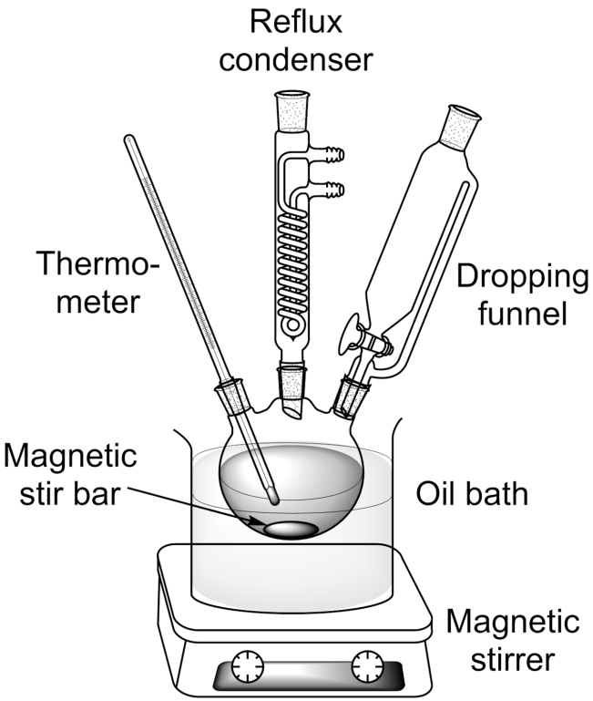
Figure 1. Experimental set up for the synthesis of [C4-mim][Cl].

$Yield= \frac{n(product)}{n (educt)}= \frac{n(1-methylimidazole)}{n([C_{4}-mim][Cl])} x 100\%$ (eq. 1)
Discussion: The aprotic IL [C4-mim][Cl] can be obtained by nucleophilic substitution of 1-methylimidazole and 1-chlorobutane under solvent-free conditions. The reaction is slightly exothermal as observed by the temperature increase upon the addition of the chloroalkane. The viscosity increase during the reaction is attributed to the formation of the IL showing a higher viscosity than the molecular precursors. The IL has a high polarity resulting from its ionic constitution resulting in a very low miscibility with ethyl acetate with has a comparably low polarity forming a biphasic system. By this way ethyl acetate can be used as extraction agent for the removal of excess educts or molecular impurities formed during the synthesis. If the IL is not dried in oil pump vacuum some traces of 1-methylimidazole may remain in the product. Anyway the IL is sufficiently pure and suitable for the experiments described in the manuscript. A yield of about 80% is observed for the reaction performed this way.

1.2 Synthesis of triethylammonium methanesulfonate [Et₃NH][SO₃Me]
The protic ionic liquid triethylammonium methanesulfonate [Et₃NH][SO₃Me] is synthesized by acid-base neutralization reaction as shown in scheme 2. The procedure can in principle be scaled up or down according to individual needs. For larger upscaling an appropriate cooling is recommended as the reaction is highly exothermic. The given amounts needed for the preparation are calculated to quantitative yield. A slight excess of triethylamine is used to ensure stoichiometric reaction and absence of methanesulfonic acid in the resulting IL.
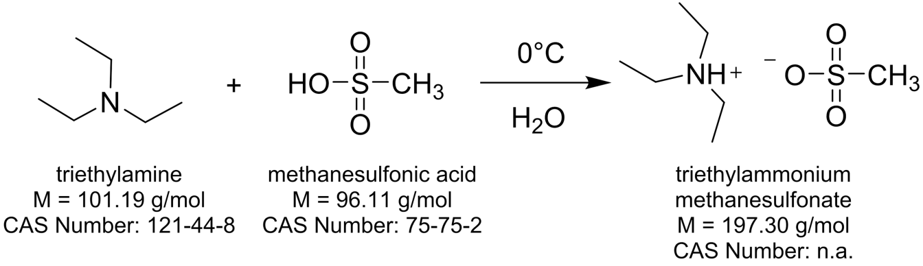
Scheme 2. Synthesis of [Et₃NH][SO₃Me] by acid-base neutralization of trimethylamine and methane sulfonic acid.
Equipment and glassware: 500 mL two-necked round bottom flask, thermometer with adapter, dropping funnel, graduated cylinder, magnetic stirrer, magnetic stir bar, rotary evaporator or distillation apparatus, oil-pump and cooling trap (optional).
Chemicals: triethylamine, methane sulfonic acid, distilled water. The corresponding GHS-classifications along with hazard and precaution statements are listed in Table 3. The amounts of substances for 100 g theoretical yield are given in Table 4.
Table 3. GHS-classification along with hazards and precaution statements for the synthesis of [Et₃NH][SO₃Me].
Substance name | CAS-Number | GHS-classification | H-phrases | P-phrases
triethylamine | 121-44-8 | GHS02, GHS05, GHS06 | H225-H302-H311 + H331-H314-H335 | P210-P261-P280-P303 + P361 + P353-P305 + P351 + P338-P370 + P378
methanesulfonic acid | 75-75-2 | GHS05, GHS07 | H290-H302 + H312-H314-H335 | P301 + P312 + P330-P303 + P361 + P353-P304 + P340 + P310-P305 + P351 + P338
[Et₃NH][SO₃Me] | - | not yet classified
Table 4. Amount of substances for the synthesis of [Et₃NH][SO₃Me] calculated for 100 g theoretical yield.
Substance name | Equivalents | Molar mass  [g/mol] | Amount of substance [mmol] | Mass  [g] | Density  [g/mL] | Volume  [mL]
triethylamine | 1.15 | 101.19 | 58.3 | 59.0 | 0.73 | 80.8
methanesulfonic acid | 1.00 | 96.11 | 50.7 | 48.7 | 1.48 | 32.9
distilled water | - | 18.02 | - | - | - | 200

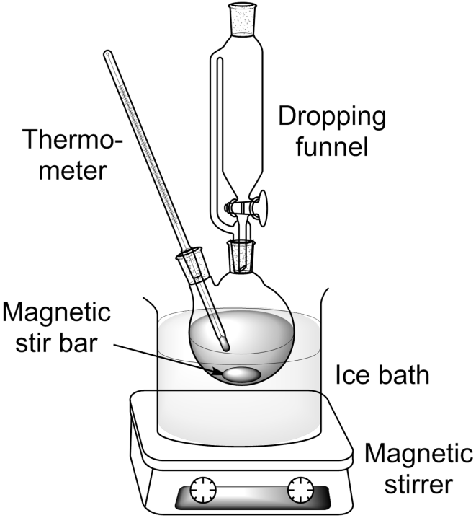
Figure 2. Experimental set up for the synthesis of [Et₃NH][SO₃Me].
Experimental: The reaction set-up is built as shown in figure 2 by connecting the two-neck round bottom flask with inner thermometer and dropping funnel. 200 mL of distilled water are placed in the flask, cooled under stirring to 0°C and the methanesulfonic acid added dropwise while remaining at constant temperature. After completion of the addition, the measured volume of triethylamine is placed in the dropping funnel and carefully added while keeping the inner temperature below 20°C. The obtained clear, colorless solution is stirred for ten minutes and the excess of triethylamine and major amount of water removed by rotary evaporation or vacuum distillation. The obtained IL is finally dried in oil pump vacuum using a cooling trap at 80°C for one day. After drying the product can be weighted to determine the yield according to equation 2. The final IL is either observed as a colorless, transparent solid or as a colorless, transparent supercooled liquid that can undergo spontaneous crystallization. The occurrence of supercooling is a very common phenomenon found in the field of ILs and is a result of the molecular design to destabilize the crystal structure to obtain salts with low melting points. The purity of the final IL is again best checked by proton-NMR. ¹H-NMR and ¹³C{¹H}-NMR spectra for [Et₃NH][SO₃Me] are shown in Figure 6 and Figure 7.
¹H-NMR (400 MHz, DMSO-d₆) δ[ppm] = 9.12 (s, 1H), 3.09 (qd, J = 7.3, 5.0 Hz, 6H), 2.37 (s, 3H), 1.18 (t, J = 7.3 Hz, 9H).
¹³C{¹H}-NMR (101 MHz, DMSO-d₆) δ[ppm] = 45.72, 39.74, 8.56.
$Yield= \frac{n(product)}{n (educt)}= \frac{n(triethylamine)}{n([Et3NH][SO3Me])} x 100\%$ (eq. 2)
Discussion: The protic [Et₃NH][SO₃Me] can be observed by acid-base neutralization of triethylamine and methanesulfonic acid in aqueous media. The reaction is highly exothermic so that intensive cooling needs to be applied. The synthesis demands only water as solvent making it an environmental benign synthesis. In addition the reaction proceeds in quantitative yield as seen from the weighted product and the absence of impurities in the NMR-spectra. From economic and ecological perspective the application of protic ionic liquids is favorable as the reactions are faster, have quantitative yields and can be performed at ambient temperatures.

2. Full hazards and precaution statements for the chemicals used in the main manuscript
Table 5. GHS-classification along with hazards and precaution statements for dissolution and processing of the biopolymers in the ionic liquids.
Substance name | CAS-Number | GHS-classification | H-phrases | P-phrases
[C4-mim][Cl] | 79917-90-1 | GHS06, GHS09 | H315-H319-H335 | P261-P280-P305 + P351 + P338-P304 + P340-P362-P312-P321-P405-P403 + P233-P501a
[Et₃NH][SO₃Me] | - | not yet classified
cellulose | 9004-34-6 | none | none | none
kraft- lignin, alkali | 8068-05-1 | none | none | none
adipoyl dichloride | 111-50-2 | GHS05 | H314 | P280-P305 + P351 + P338-P310
Bisphenol A diglycidyl ether | 1675-54-3 | GHS07 | H315-H317-H319 | P280-P305 + P351 + P338
4,4'-methylene diphenyl diisocyanate | 101-68-8 | GHS07, GHS08 | H315-H317-H319-H332-H334-H335-H351-H373 | P260-P280-P284-P304 + P340-P305 + P351 + P338-P342 + P31

3. The twelve principles of green chemistry as guideline for sustainable development in chemistry

3.1 Introduction of the green chemistry guidelines
The twelve principles of green chemistry were first published by Paul Anastas and John C. Warner to offer scientist a guideline for sustainable development from chemical and chemical engineering point of view.¹ The aim of the research in green chemistry or sustainable chemistry is the design of more environmental benign products, techniques and processes that support a sustainable development on ecologic, economic and social levels. The twelve principles of green chemistry describe a variety of possibilities to minimize the amount of hazardous substances used, environmental pollution and consumption of finite resources in all stages of production and life circle of the obtained products.² The chemical industry is a driving force for the research and development of sustainable techniques and has a great impact on everyday life. It is therefore of great importance to adopt these principles to the highest possible degree in chemical processing and engineering and to sensitize future generations for sustainable development.
The twelve principles of green chemistry are the following:
1. Prevention of waste: Careful design of processes and reactions helps to prevent waste instead of post-treatment and cleaning up of waste.
2. Atom economy: Reactions should be designed to use the maximum of atoms from the educts incorporated in the final products to reduce the generation of side products.
3. Less Hazardous Chemical Synthesis: As far as possible chemical synthesis should avoid the usage of substances that are toxic to humans and the environment.
4. Design Safer Chemicals: All chemical products should be designed on minimizing the hazard potential while retaining their function.
5. Benign Solvents and Auxiliars: The application of auxiliary chemicals like solvents, separation agents etc. should be avoided as far as possible. If this is not applicable the usage should be innocuous.
6. Design for Energy Efficiency: Energetic input into chemical reactions and processes should be minimized.
7. Use of Renewable Feedstocks: Raw materials and products made thereof should be from renewable feedstocks if practicable.
8. Reduce Derivatives: Derivatization should be avoided to reduce the amount of synthesis steps required and the generation of waste.
9. Catalysis: Selective catalysts should be preferred instead of stoichiometric usage of chemicals to reduce further waste and energy input.
10. Design for degradation: The design of chemical products should allow the breaking into innocuous, non-persistent substances at the end of their function
11. Real-time analysis for Pollution Prevention: Analytical methods for real-time monitoring and control should be applied as they can prevent the generation of waste or hazardous chemicals
12. Inherent Safer Chemistry: Chemicals used should be chosen to minimize their danger potential and thereby the risk of accidents, explosions and releases.

3.2 Evaluation of the experiments in the context of green chemistry
In order to show the great potential of ILs for the pretreatment and processing of biomass it is helpful to evaluate the knowledge gained from the experiments as described in the main part in the context of a sustainable chemistry and development. Therefore the benefits of the IL usage in biomass pretreatment, processing and the obtained lignin-based polymers are discussed according to the twelve principles of green chemistry in comparison with the currently applied industrial technologies.

3.2.1 Biomass pretreatment using ionic liquids
As biomass pretreatment to remove lignin and obtain cellulose is in most cases the first step in the usage of renewable sources and is widely used in industry. Among the different technologies the kraft process for pulp milling is the most dominant covering about 85% of the worldwide lignin production.³ As this process is highly energy consuming the lignin generated from the pulping is burnt as low grad fuel to cover the energy demands. The usage of ILs in the biomass pretreatment process (some of them are referred to as “Ionosolv”^{4, 5})for a selective lignin removal could generate lignin of higher purity that better fits the need of material usage like the absence of sulfur in the lignins. Material usage of lignin to value added products could include the depolymerization into functionalized low-molecular compounds or the generation of polymers as shown in the main part of the manuscript.⁶ Some of the potential benefits by using IL as solvents for biomass pretreatment compared to the kraft process are summarized in Table 6.

Table 6. Fulfilment of the green chemistry principles of biomass pretreatment using ionic liquids in comparison to the kraft process as dominating industrial technique.
 | Green Chemistry Principle | Conventional method (kraft process as dominating industrial example) | Pretreatment using ionic liquids
1 | Waste prevention | Several additional chemicals needed (e.g. sodium hydroxide, sodium sulfide, several byproducts), sulfur containing lignin of lower quality | No additional reagents needed as ILs have strong solvation ability for biomass, sulfur-free lignin can be obtained for further material usage
2 | Atom economy | Byproducts and incomplete workup, black liquor containing lignin is usually burnt | In principle complete material usage of components and full recovery of solvent
3 | Less hazardous chemical syntheses | Malodorous harmful gases, toxic sodium sulfide, corrosive sodium hydroxide | ILs as stable, nonvolatile, non-inflammable solvents, tunable towards non-toxicity
4 | Design safer chemicals | - | Intrinsically safer solvents, widely tailorable to reduce impact on organisms
5 | Safer solvents and auxiliaries | No potential harmful organic solvents used | No potential harmful organic solvents used
6 | Energy efficiency | Several hours at about 170°C and additional pressure application | Several hours at slightly elevated temperatures and ambient pressure
7 | Use of renewable feedstocks | Usage of biomass (wood) | Usage of biomass, possibility of bio-derivated ILs demonstrated⁷
8 | Reduce derivatives | No derivatization (no chemical transformation) | No derivatization (no chemical transformation)
9 | Catalysis | Not applied (no chemical transformation) | Not applied (no chemical transformation)
10 | Design for degradation | No biodegradation implied | Biodegradable ILs are reported
11 | Real-time analysis for pollution prevention | In principle applicable | In principle applicable
12 | Inherently safer chemistry for accident prevention | High temperature and pressure, toxic and corrosive chemicals pose treats | Minimized hazard potential through processing at ambient pressure and less toxic, inflammable solvents

3.2.2 Biomass processing using ionic liquids
The processing of biological polymers like cellulose and lignin is lacking practicable and environmental friendly solvents. Especially the processing of cellulose traditionally via the cuprammonium or xanthate (viscose) process uses high amounts of additives that are toxic and hard to recycle.⁸ The viscose process is still the most often used industrial cellulose processing but lacks from extensive use of chemicals through the derivatization and regenerating process.⁹ The process converts the initial cellulose to alkali cellulose by treatment with aqueous NaOH followed by derivatization to the water soluble cellulose xanthate as sketched in figure 3. Cellulose processing using the xanthate demands large amounts of additives that are corrosive (sodium hydroxide, sulfuric acid) or volatile, toxic and highly inflammable (carbon disulfide). As some pure hydrophilic ILs show a high solution power for cellulose without the need for additional reagents and simple regeneration of the ionic solvent by separation upon water addition they offer a possible safer and environmentally friendlier option for this large scale application. Table 7 summarizes the benefits according to the twelve principles of green chemistry that an IL-based cellulose processing offers over the viscose process. A process for larger scale production of so called Ioncell-F cellulose is currently under development and shows promising properties and performance.¹⁰ Because of the high solvation power of ionic liquids they are also able to dissolve other biopolymers besides cellulose and thus offer the ability to generate composites of modified or non-modified polymers that have tunable properties. An interesting example for material science, the “synthetic wood”¹¹ consisting of different amounts of lignin and cellulose, is demonstrated in the main manuscript.
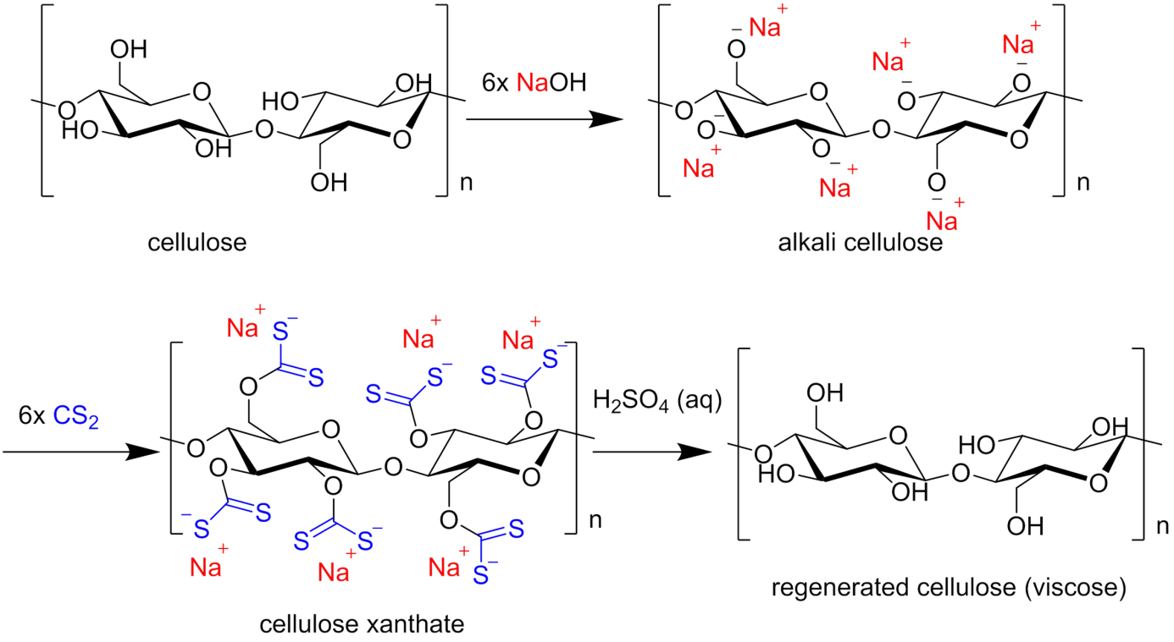
Figure 3. The conventional industrially applied viscose process for the processing of cellulose.

Table 7. Green chemistry principles of cellulose processing using ionic liquids compared to the viscose process as widespread industrial processing.
 | Green Chemistry Principle | Conventional method (viscose process via xanthate intermediate as widespread example) | Cellulose processing using ionic liquids
1 | Waste prevention | Large amounts of additional chemicals needed (e.g. sodium hydroxide, sulfuric acid, CS₂) that can only be regenerated in minor amounts | No additional reagents needed as ILs have strong solvation ability for biomass; in principle full solvent recovery
2 | Atom economy | Poorly through use of derivatization reagents and incomplete or impracticable work up | High as no derivatization reactions applied and full solvent recovery to create closed processing circle
3 | Less hazardous chemical syntheses | Volatile, flammable and toxic CS₂, corrosive sodium hydroxide and sulfuric acid | ILs as stable, nonvolatile, non-flammable solvents, tunable towards non-toxicity
4 | Design safer chemicals | - | Intrinsically safer solvents, widely tailorable to reduce impact on organisms
5 | Safer solvents and auxiliaries | Water as safe, benign solvent but a number of harmful additives | No potential harmful organic solvents used
6 | Energy efficiency | No high temperature and ambient pressure | Several hours at elevated temperatures and ambient pressure
7 | Use of renewable feedstocks | Utilization of biomass for products of daily life | Usage of biomass, possibility of bio-derivated ILs demonstrated⁷
8 | Reduce derivatives | Non-optional derivatization steps to cellulose xanthate | No derivatization (no chemical transformation)
9 | Catalysis | Not applied (no chemical transformation) | Not applied (no chemical transformation)
10 | Design for degradation | No biodegradation implied | Biodegradable ILs are reported
11 | Real-time analysis for pollution prevention | In principle applicable | In principle applicable
12 | Inherently safer chemistry for accident prevention | Volatile, inflammable, toxic and corrosive chemicals pose treats | Minimized hazard potential through less toxic, non-volatile, non-inflammable solvents

3.2.3 Biopolymers based on lignin
The material usage of lignin is of great industrial interest as it allows the generation of value added products instead of the underutilization as combustion material. Beside the usage as renewable, fossil-fuel independent feedstock of aromatic compounds the implementation as biological macro-monomer seems to be the most promising practical usage. Especially the biodegradability and cost-efficiency of lignin and polymers based on this phenolic compound is a promising benefit for the sustainability of this products.¹² The high chemical resistance and UV-absorption of lignin may further introduce demanded properties to the final polymers. The unique branched aromatic structure of lignin makes it, for example, a promising candidate for plastics or the substitution of synthetic polymers.¹³ With ionic liquids recognized as new and tailorable solvents for even high weight percentages of different types of lignin and other biopolymers new opportunities for novel macromolecular compounds and processes are arising.¹⁴ Also synergetic effects using lignin-isolation with ILs followed by direct polymerization in the thereby obtained lignin solutions arise. As hydroxyl-units are the abundant reactive groups in the lignin structure most research is focusing either on the direct polymerization or the derivatization of the hydroxyl groups with subsequent polymerization. A number of benefits of lignin-based polymers using ILs as solvents for polymerization are listed in Table 8 and compared to the industrial polymers based on fossil fuel.

Table 8. Green chemistry principles applied to lignin based polymers in comparison to polymers based on mineral oil.
 | Green Chemistry Principle | Polymers based on mineral oil | Lignin-based polymers
1 | Waste prevention | In most cases no additional solvent needed; non-biodegradable plastic waste in maritime ecosystems poses serious problems today and even more in the future | No additional reagents for the dissolution needed as ILs have strong solvation ability for biomass; in principle full solvent recovery; improved biodegradability advantageous if waste exposed to ecosystems
2 | Atom economy | High atom economy | High atom economy and in principle full solvent recovery
3 | Less hazardous chemical syntheses | Commonly applied are flammable, toxic volatile monomers and organic solvents (if used) | Lignin is an inflammable, non-volatile educt; ILs are stable, nonvolatile, non-flammable solvents, tunable towards non-toxicity
4 | Design safer chemicals | - | Lignin based polymers are in general as benign as conventional polymers; Intrinsically safer solvents, widely tailorable to reduce impact on organisms
5 | Safer solvents and auxiliaries | Often solvent-free otherwise conventional organic solvents | No potential harmful organic solvents used
6 | Energy efficiency | Depending on type of polymerization and process | Polymerization in solution may improve energy efficiency through improved reaction kinetics
7 | Use of renewable feedstocks | No use of biomass; not CO₂-benign | Usage of biomass, possibility of bio-derivated ILs demonstrated⁷, CO₂-balance improved
8 | Reduce derivatives | Usually no derivatization | Usually no derivatization
9 | Catalysis | Often applied | In principle applicable but only few scientific investigations
10 | Design for degradation | Usually very poor biodegradability | Biodegradable ILs are reported; biodegradability of polymers highly improved
11 | Real-time analysis for pollution prevention | In principle applicable | In principle applicable
12 | Inherently safer chemistry for accident prevention | Volatile, inflammable, toxic and corrosive chemicals pose treats | Minimized hazard potential through less toxic, non-volatile, non-inflammable solvents

4. NMR-spectra of the synthesized ILs.

4.1 NMR-spectra of [C₄-mim][Cl]
Figure 4 ¹H-NMR spectra of [C₄-mim][Cl].
Figure 5. ¹³C{¹H}-NMR spectra of [C₄-mim][Cl].
4.2 NMR-spectra of [Et₃NH][SO₃Me]
Figure 6. ¹H-NMR spectra of [Et₃NH][SO₃Me].
Figure 7. ¹³C{¹H}-NMR spectra of [Et₃NH][SO₃Me].

5. References
(1) Warner, P. A. J. Green Chemistry: Theory and Practice; Oxford University Press, 2000.
(2) Poliakoff, M.; Fitzpatrick, J. M.; Farren, T. R.; Anastas, P. T. Science (80-. ). 2002, 297 (5582), 807–810.
(3) Galkin, M. V.; Samec, J. S. M. ChemSusChem 2016, 9 (13), 1544–1558.
(4) Brandt, A.; Chen, L.; van Dongen, B. E.; Welton, T.; Hallett, J. P. Green Chem. 2015, 17 (11), 5019–5034.
(5) Prado, R.; Erdocia, X.; Labidi, J. J. Clean. Prod. 2016, 111, 125–132.
(6) Rinaldi, R.; Jastrzebski, R.; Clough, M. T.; Ralph, J.; Kennema, M.; Bruijnincx, P. C. A.; Weckhuysen, B. M. Angew. Chemie Int. Ed. 2016, 55 (29), 8164–8215.
(7) Socha, A. M.; Parthasarathi, R.; Shi, J.; Pattathil, S.; Whyte, D.; Bergeron, M.; George, A.; Tran, K.; Stavila, V.; Venkatachalam, S.; Hahn, M. G.; Simmons, B. a; Singh, S. Proc. Natl. Acad. Sci. 2014, 111 (35), E3587–E3595.
(8) Zhu, S.; Wu, Y.; Chen, Q.; Yu, Z.; Wang, C.; Jin, S.; Ding, Y.; Wu, G. Green Chem. 2006, 8 (4), 325.
(9) Cao, Y.; Wu, J.; Zhang, J.; Li, H.; Zhang, Y.; He, J. Chem. Eng. J. 2009, 147 (1), 13–21.
(10) Sixta, H.; Michud, A.; Hauru, L.; Assadi, S.; Ma, Y.; King, A. W. T.; Kilpeläinen, I.; Hummel, M. Nord. Pulp Pap. Res. J. 2015, 30 (1), 043–057.
(11) Simmons, T. J.; Lee, S. H.; Miao, J.; Miyauchi, M.; Park, T.-J.; Bale, S. S.; Pangule, R.; Bult, J.; Martin, J. G.; Dordick, J. S.; Linhardt, R. J. Wood Sci. Technol. 2011, 45 (4), 719–733.
(12) Upton, B. M.; Kasko, A. M. Chem. Rev. 2016, 116 (4), 2275–2306.
(13) Sun, J.; Wang, C.; Yeo, J. C. C.; Yuan, D.; Li, H.; Stubbs, L. P.; He, C. Macromol. Mater. Eng. 2016, 301 (3), 328–336.
(14) Wu, R.-L.; Wang, X.-L.; Li, F.; Li, H.-Z.; Wang, Y.-Z. Bioresour. Technol. 2009, 100 (9), 2569–2574.

